# PROGRAM-1

## Write a program in HTML to print hello world.

### Code:

<html>

<head><title> Hello World </title></head>

<body align='center'>

Hello World. This is Arushi Sharma.

<p> Program 1 of Web technology Lab.

</body>

</html>

Output:

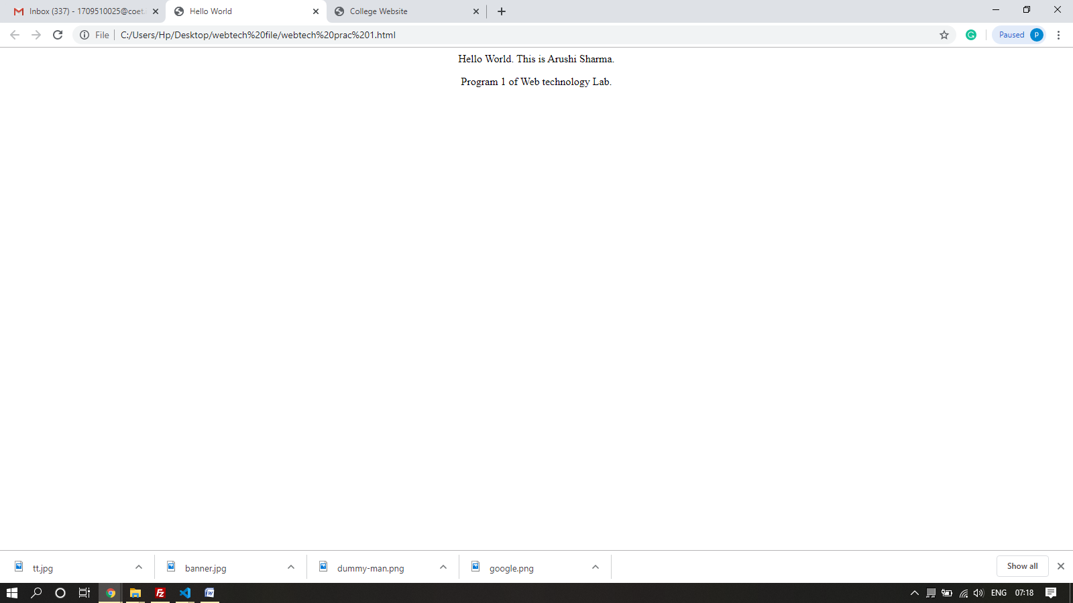

# PROGRAM-2

## Write a program in HTML to create your own Google page.

### Code:

<html>

<head>

<title> Google </title>

</head>

<body>

<header align="right"> Gmail Images

</header>

<p style="text-align:center;">

<br><br><br><br><br>

<img src="google.png" width="500">

<br>

<input type="search" class="search">

<br>

<input type="submit" class="button" value="Google Search">

<input type="submit" class="button" value="I'm Feeling Lucky">

</p>

</body>

</html>

Output:

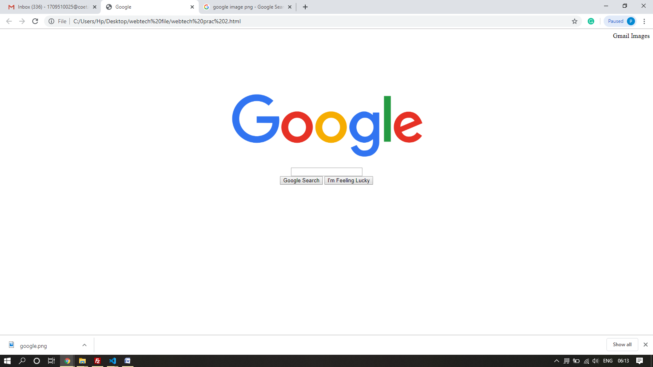

# PROGRAM-3

## Write a program in HTML to display your CV in navigator, your Institute Website, Department Website and Tutorial website for specific subject.

## Code:

<!DOCTYPE html>

<html>

<head>

    <title>College Website</title>

    <link rel="stylesheet" href="https://maxcdn.bootstrapcdn.com/bootstrap/4.3.1/css/bootstrap.min.css">

    <script src="https://ajax.googleapis.com/ajax/libs/jquery/3.4.1/jquery.min.js"></script>

    <script src="https://cdnjs.cloudflare.com/ajax/libs/popper.js/1.14.7/umd/popper.min.js"></script>

    <script src="https://maxcdn.bootstrapcdn.com/bootstrap/4.3.1/js/bootstrap.min.js"></script>

</head>

<body>

    <div class="jumbotron">

        <img src="banner.jpg" style="width:100%;">

    </div>

    <div align="center">

        <button type="button" class="btn btn-outline-info">About Us</button>

        <button type="button" class="btn btn-outline-info">Contact Us</button>

        <a href="webtech prac 3.html"><button type="button" class="btn btn-outline-info">Student's CV</button></a>

    </div>

</body>

</html>

<!DOCTYPE html>

<html>

<head>

    <title>College Website</title>

    <link rel="stylesheet" href="https://maxcdn.bootstrapcdn.com/bootstrap/4.3.1/css/bootstrap.min.css">

    <script src="https://ajax.googleapis.com/ajax/libs/jquery/3.4.1/jquery.min.js"></script>

    <script src="https://cdnjs.cloudflare.com/ajax/libs/popper.js/1.14.7/umd/popper.min.js"></script>

    <script src="https://maxcdn.bootstrapcdn.com/bootstrap/4.3.1/js/bootstrap.min.js"></script>

</head>

<body>

    <div class="jumbotron">

        <div align="center">

            <h2 class="display-2">

                CURRICULUM VITAE

            </h2>

        </div>

    </div>

    <div align="center">

        <div class="row">

            <div class="col" style="">

                <img src="dummy-man.png" style="height: 50%;">

                <br>

                <h3>Arushi Sharma</h3>

            </div>

            <div class="col" style="">

                <h2>Contact Details</h2>

                <div><b>Address:</b> Vasundra</div>

                <div><b>Mobile No.:</b> NIL</div>

                <div><b>E-mail:</b>arushisharma@gmail.com</div>

            </div>

        </div>

    </div>

</body>

</html>

Output:

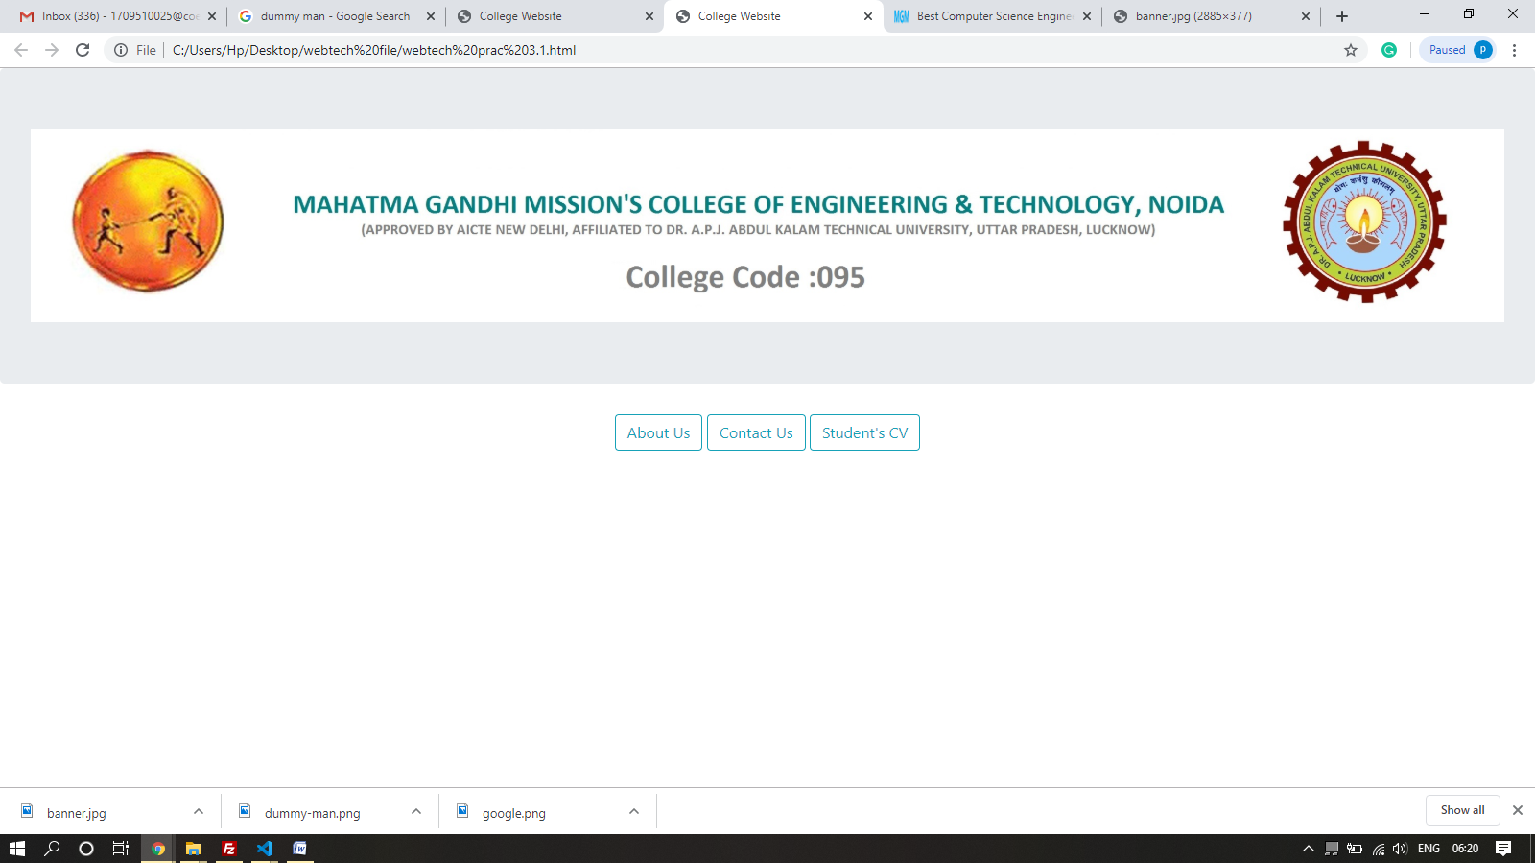

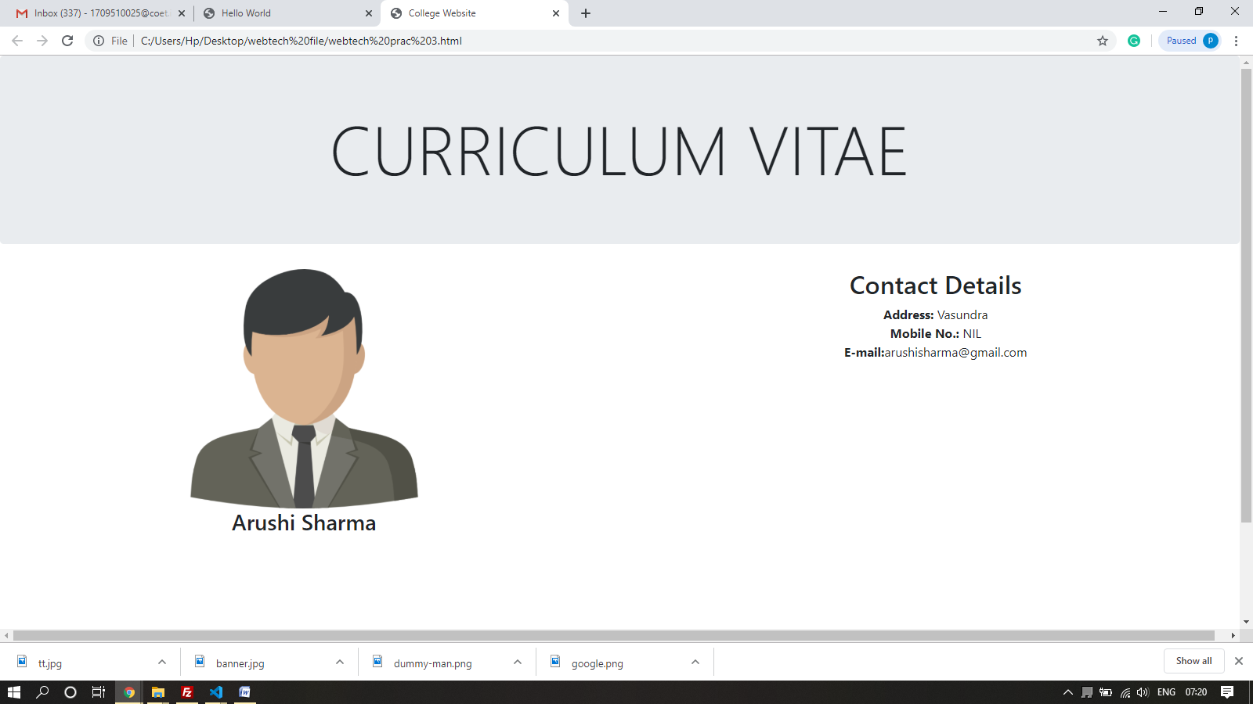

# PROGRAM-4

## Write an HTML program to design an entry form of student details and send it to store at database server like SQL, Oracle or MS Access.

## Code:

<html>

<head>

    <title>Student Form</title>

</head>

<body align="center">

    <h1 align="center">Enter all the Details</h1>

    <form>

        Full Name:&emsp;&ensp;

        <input type="text" name="Name"><br> College Name:

        <input type="text"><br> Course:

        <select name="course">

            <option value="B.Tech">B.Tech</option>

            <option value="M.Tech">M.Tech</option>

        </select>&emsp;&emsp; Branch:

        <select name="branch">

            <option value="Civil">Civil</option>

            <option value="Mechanical">Mechanical</option>

            <option value="Electrical">Electrical</option>

            <option value="CSE">CSE</option>

        </select><br> Roll No:

        <input type="text" name="Roll"><br><br>

        <input type="submit" value="Submit">

    </form>

</body>

</html>

Output:

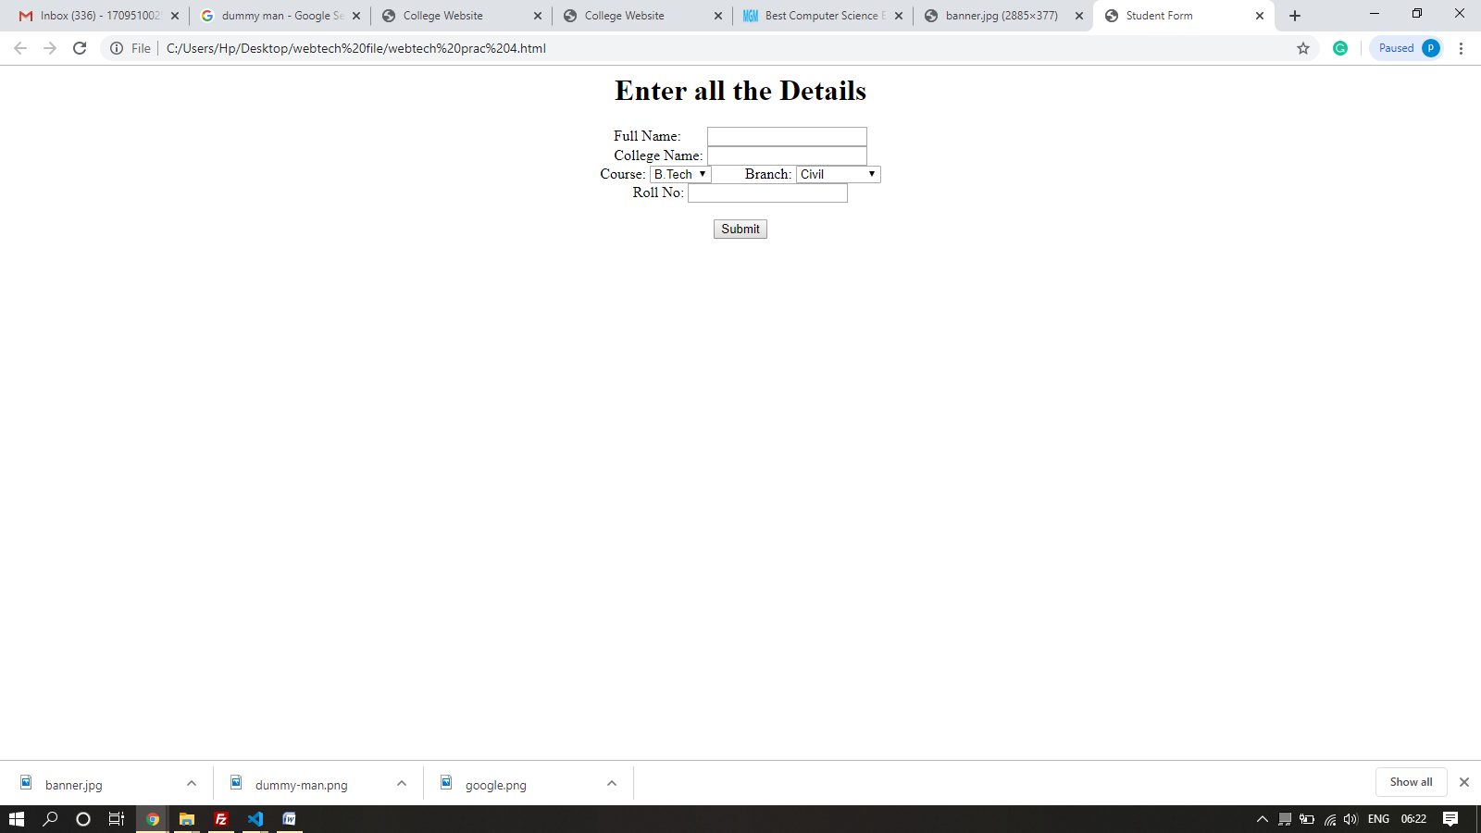

# PROGRAM-5

## Demonstrate the use of style sheet in HTML.

## Code:

<html>

<head>

    <title>Student Form</title>

    <link rel="stylesheet" href="styles.css">

</head>

<body align="center">

    <h1 align="center">Enter all the Details</h1>

    <form>

        Full Name:&emsp;&ensp;

        <input type="text" name="Name"><br> College Name:

        <input type="text"><br> Course:

        <select name="course">

            <option value="B.Tech">B.Tech</option>

            <option value="M.Tech">M.Tech</option>

        </select>&emsp;&emsp; Branch:

        <select name="branch">

            <option value="Civil">Civil</option>

            <option value="Mechanical">Mechanical</option>

            <option value="Electrical">Electrical</option>

            <option value="CSE">CSE</option>

        </select><br> Roll No:

        <input type="text" name="Roll"><br><br>

        <input type="submit" value="Submit">

    </form>

</body>

</html>

**STYLES.CSS**

body { align:"center";

    background-image:url("tt.jpg"); background-size:100% 100%;

    }

    h1 {

    color: red;

    }

    form{

    color: yellow;

    }

Output:

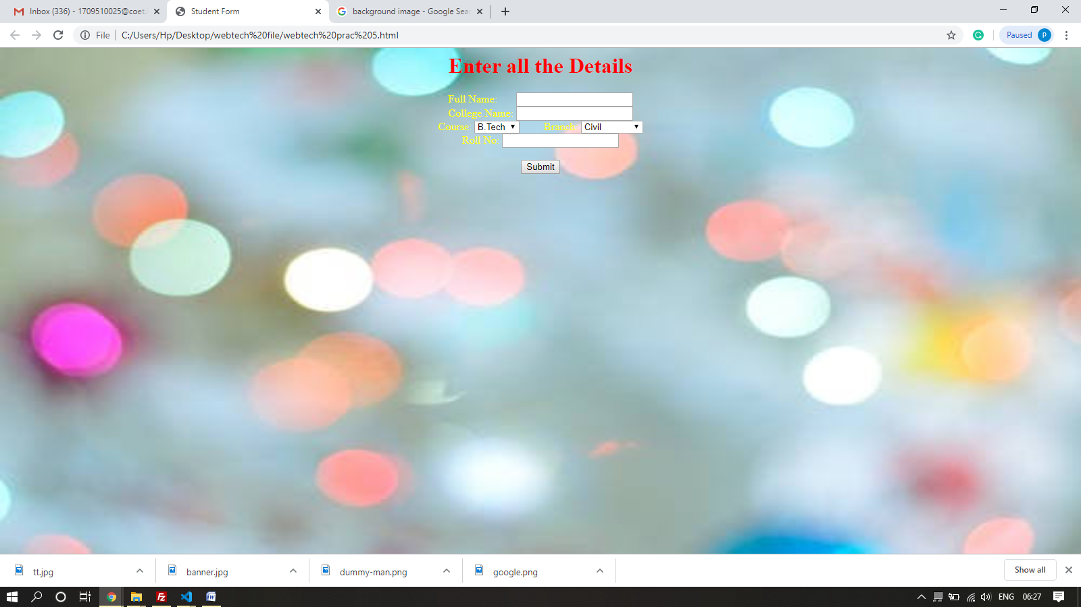

# PROGRAM-6

## Write programs using Java script for Web Page to display browsers information.

## Code:

<html>

<head>

    <title>Browser Information</title>

</head>

<body>

    <h1>Browser Information</h1>

    <hr>

    <p>

        The <b>navigator</b> object contains the following information about the browser you are using.

    </p>

    <ul>

        <script LANGUAGE="JavaScript" type="text/javascript"> document.write("<li><b>Code Name:</b> " + navigator.appCodeName); document.write("<li><b>App Name:</b> " + navigator.appName); document.write("<li><b>App Version:</b> " + navigator.appVersion); document.write("<li><b>User Agent:</b> " + navigator.userAgent); document.write("<li><b>Language:</b> " + navigator.language); document.write("<li><b>Platform:</b> " + navigator.platform);

        </script>

    </ul>

    <hr>

</body>

</html>

Output:

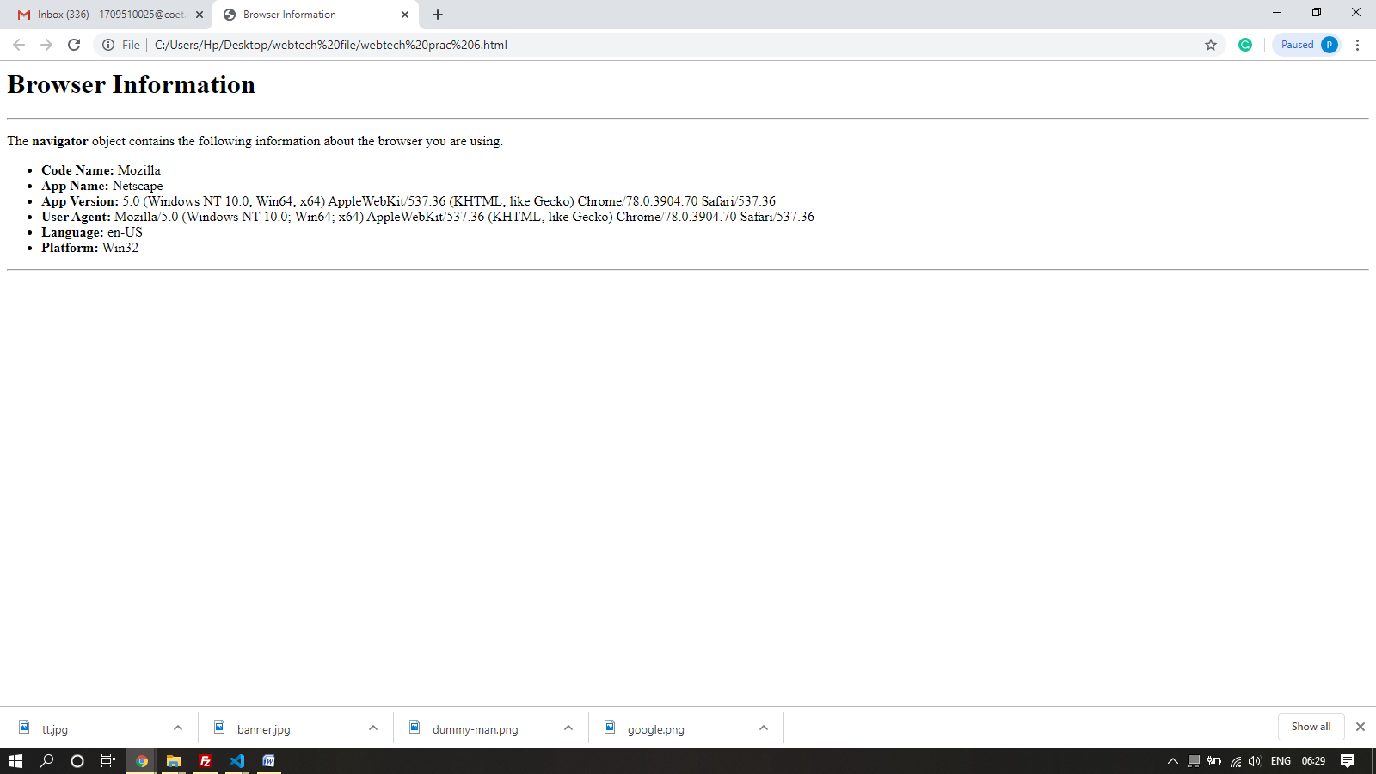

# PROGRAM-7

Install TOMCAT web server and APACHE.

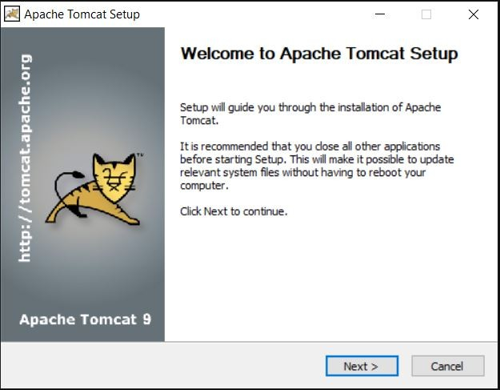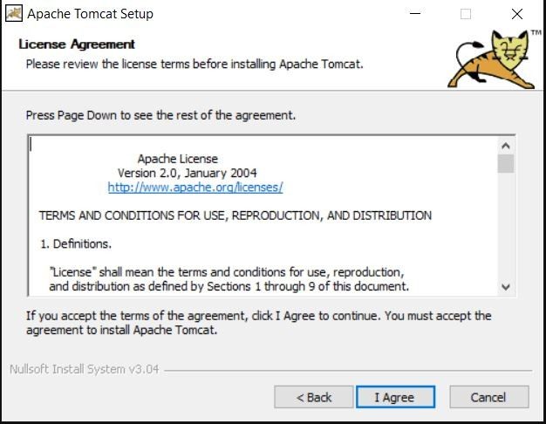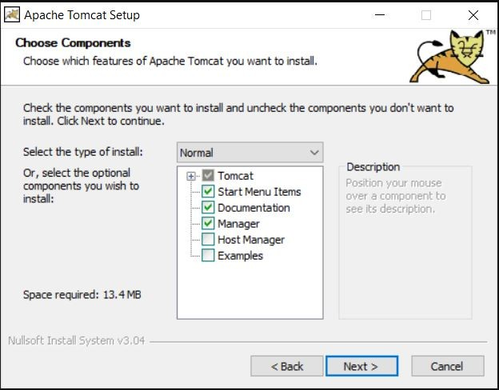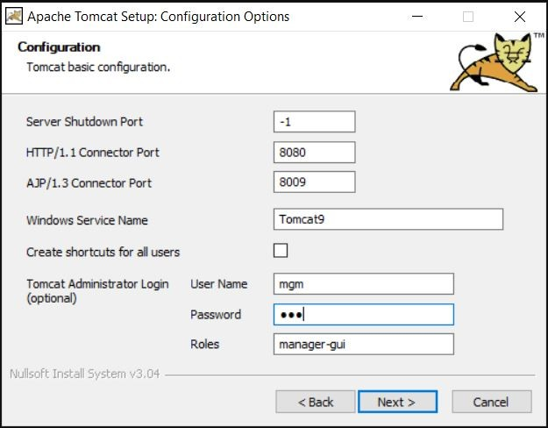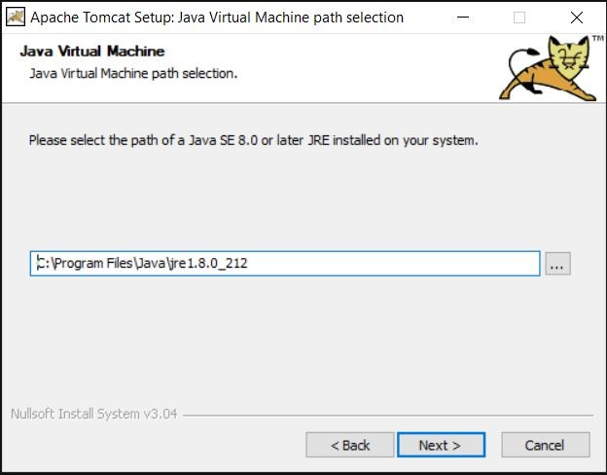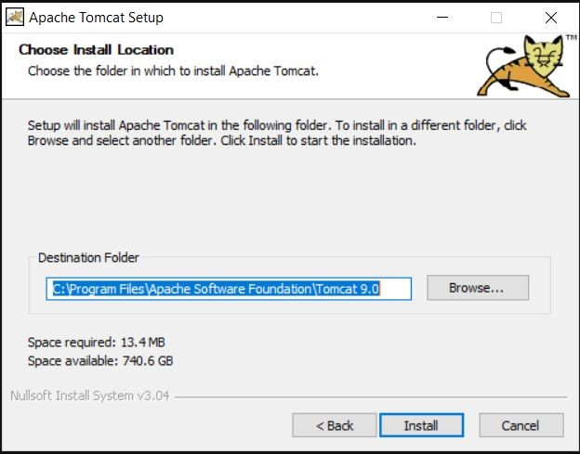

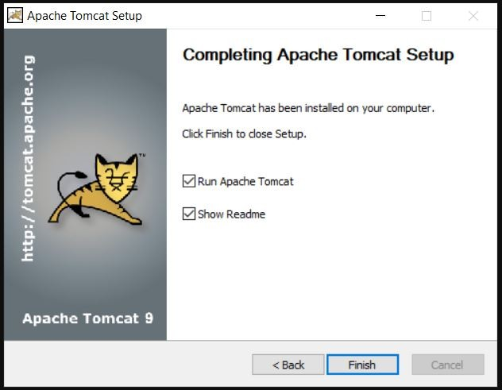

# PROGRAM-8

Write a Program to use java applet in HTML.

**Open Notepad and Type the following code and save it as “First.java”.**

Code:

import java.applet.Applet; import java.awt.Graphics; public class First extends Applet

    {

        public void paint(Graphics g)

            {

                g.drawString("welcome",300,300);

            }

    }

**Now Make another file named as “myapplet.html” with the following code:**

<html>

<body>

    <applet code="First.class" width="500" height="500">

    </applet>

</body>

</html>

**Open Command Prompt and change the destination to the folder where you have saved these two files.**

**Now type “javac First.java” and this will make a new file in your folder named “First.class”. Now type “appletviewer myapplet.html” and Java applet will appear with the message.**

Output:

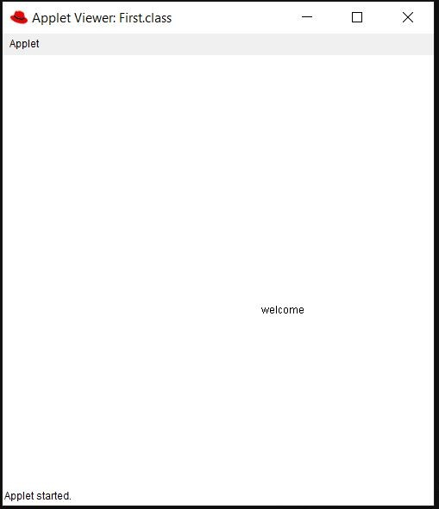

# PROGRAM-9

Write a Java applet to display the Application Program screen i.e. calculator.

Code for cal.java:

import java.awt.*; import java.awt.event.*; import java.applet.*;

/*

<applet code="cal" width=300 height=300>

</applet>

*/

public class cal extends Applet implements ActionListener

{

    String msg=" "; int v1,v2,result; TextField t1;

    Button b[]=new Button[10];

    Button add,sub,mul,div,clear,mod,EQ; char OP;

    public void init()

        {

            Color k=new Color(120,89,90); setBackground(k);

            t1=new TextField(10);

            GridLayout gl=new GridLayout(4,5); setLayout(gl);

            for(int i=0;i<10;i++)

                {

                    b[i]=new Button(""+i);

                }

            add=new Button("add"); sub=new Button("sub"); mul=new Button("mul"); div=new Button("div"); mod=new Button("mod"); clear=new Button("clear"); EQ=new Button("EQ"); t1.addActionListener(this);

            add(t1);

            for(int i=0;i<10;i++)

                {

                    add(b[i]);

                }

            add(add);

            add(sub);

            add(mul);

            add(div);

            add(mod); add(clear); add(EQ);

            for(int i=0;i<10;i++)

                {

                    b[i].addActionListener(this);

                }

            add.addActionListener(this); sub.addActionListener(this); mul.addActionListener(this); div.addActionListener(this); mod.addActionListener(this); clear.addActionListener(this); EQ.addActionListener(this);

        }

    public void actionPerformed(ActionEvent ae)

        {

            String str=ae.getActionCommand(); char ch=str.charAt(0);

            if ( Character.isDigit(ch)) t1.setText(t1.getText()+str); else

            if(str.equals("add"))

                {

                    v1=Integer.parseInt(t1.getText()); OP='+';

                    t1.setText("");

                }

            else if(str.equals("sub"))

                {

                    v1=Integer.parseInt(t1.getText());

                    OP='-';

                    t1.setText("");

                }

            else if(str.equals("mul"))

                {

                    v1=Integer.parseInt(t1.getText()); OP='*';

                    t1.setText("");

                }

            else if(str.equals("div"))

                {

                    v1=Integer.parseInt(t1.getText()); OP='/';

                    t1.setText("");

                }

            else if(str.equals("mod"))

                {

                    v1=Integer.parseInt(t1.getText()); OP='%';

                    t1.setText("");

                }

            if(str.equals("EQ"))

                {

                    v2=Integer.parseInt(t1.getText()); if(OP=='+')

                    result=v1+v2; else if(OP=='-')

                    result=v1-v2; else if(OP=='*')

                    result=v1*v2; else if(OP=='/')

                    result=v1/v2; else if(OP=='%')

                    result=v1%v2; t1.setText(""+result);

                }

            if(str.equals("clear"))

                {

                    t1.setText("");

                }

        }

}

## Code for calci.html:

<html>

<body>

    <applet code="cal.class" width="300" height="300">

    </applet>

</body>

</html>

## Output:

## 